System Parameters:
# System connection parameters
grid_connection = 2000 # Grid connection capacity [kW]
solar_connection = 2000 # Solar connection capacity [kW]
battery_capacity = 40000 # Battery capacity [Ah]
battery_voltage = 100 # Battery voltage [V]
diesel_capacity = 2200 # Diesel generator capacity [kW]
# Hydrogen System Parameters
electrolyzer_capacity = 1000 # Max power consumption of the electrolyzer [kW]
fuel_cell_capacity = 800 # Max power generation of the fuel cell [kW]
h2_tank_capacity = 100 # Hydrogen storage tank capacity [kg]
fuel_cell_efficiency_percent = 0.60 # Fuel cell DC electrical efficiency (60%)
# Cost parameters
pv_energy_cost = 2.85 # PV energy cost [INR/kWh]
load_curtail_cost = 50 # Load curtailment penalty [INR/kWh]
battery_om_cost = 6.085 # Battery O&M cost [INR/kWh]
fuel_cell_om_cost = 1.5 # Fuel cell O&M cost [INR/kWh]
electrolyzer_om_cost = 0.5 # Electrolyzer O&M cost [INR/kWh]
fuel_price = 95 # INR per liter
# CO2 EMISSION PARAMETERS
# All in kg CO2 per kWh of electrical energy
co2_grid_import = 0.716 # Grid import [kg CO2 / kWh]
co2_diesel = 0.9 # Diesel generator [kg CO2 / kWh]
co2_battery_discharge = 0.029 # Battery discharge [kg CO2 / kWh]
co2_pv_used = 0.046 # PV used [kg CO2 / kWh]
co2_fuel_cell = 0.001 # Assume green H2, no direct CO2
co2_electrolyzer = 0.0 # Assume no direct CO2 (electricity emissions counted at source)

# High CO2-equivalent penalty for load curtailment (only used in CO₂ mode) # NEW
co2_load_curt_penalty = 5.0 # Very large penalty [kg CO2-eq / kWh curtailed]
CO₂ Minimisation Optimization
SUMMARY REPORT
Optimization Mode: CO₂ minimization
Optimization Period: 1 day(s)
Time Resolution: 60 minutes
Total Time Steps: 24
LOAD ANALYSIS:
Total Load Demand: 25100.0 kWh
Total Load Curtailed: 0.0 kWh
Total Load Served: 25100.0 kWh (100.0%)
GRID ANALYSIS:
Grid Import: 10912.0 kWh
Grid Export: 0.0 kWh
DIESEL GENERATOR ANALYSIS:
Energy Generated: 0.0 kWh
Fuel Cost: 0.00 INR
BATTERY ANALYSIS:
Energy Charged: 3200.0 kWh
Energy Discharged: 2888.0 kWh
SOLAR ANALYSIS:
Solar Available: 14500.0 kWh
Solar Used: 14500.0 kWh (100.0%)
Solar Curtailed: 0.0 kWh
HYDROGEN SYSTEM ANALYSIS:
Energy to Electrolyzer: 0.0 kWh
Energy from Fuel Cell: 0.0 kWh
Hydrogen Produced: 0.00 kg
Hydrogen Consumed: 0.00 kg
Fuel Cell O&M Cost: 0.00 INR
Round-Trip Efficiency: 0.0%
Effective Conversion: 0.00 kWh/kg

CO₂ EMISSIONS ANALYSIS:
Grid Emissions: 7812.99 kg CO₂
Diesel Emissions: 0.00 kg CO₂
Battery Emissions: 83.75 kg CO₂
PV Emissions: 667.00 kg CO₂
Fuel Cell Emissions: 0.00 kg CO₂
Electrolyzer Emissions: 0.00 kg CO₂
Curtailment Penalty: 0.00 kg CO₂-eq
──────────────────────────────────
TOTAL CO₂ (physical): 8563.74 kg CO₂
TOTAL CO₂ OBJECTIVE: 8563.74 kg CO₂-eq
Emissions per kWh served: 0.3412 kg CO₂/kWh

COST BREAKDOWN (reference only):
Grid Cost: 67807.40 INR
Diesel Fuel Cost: 0.00 INR
Solar Cost: 41325.00 INR
Battery O&M Cost: 17573.48 INR
Fuel Cell O&M Cost: 0.00 INR
Electrolyzer O&M Cost: 0.00 INR
──────────────────────────────────
TOTAL COST: 126705.88 INR
Cost per kWh served: 5.05 INR/kWh

SYSTEM CONFIGURATION:
✓ Grid Connection
✓ Diesel Generator
✓ Battery System
✓ Solar PV
✓ Hydrogen System (Electrolyzer + Fuel Cell)
Weather: Sunny Day

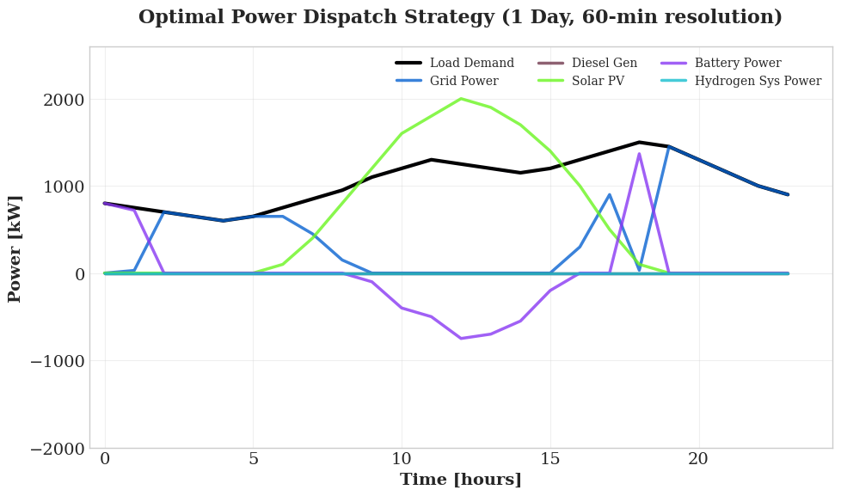

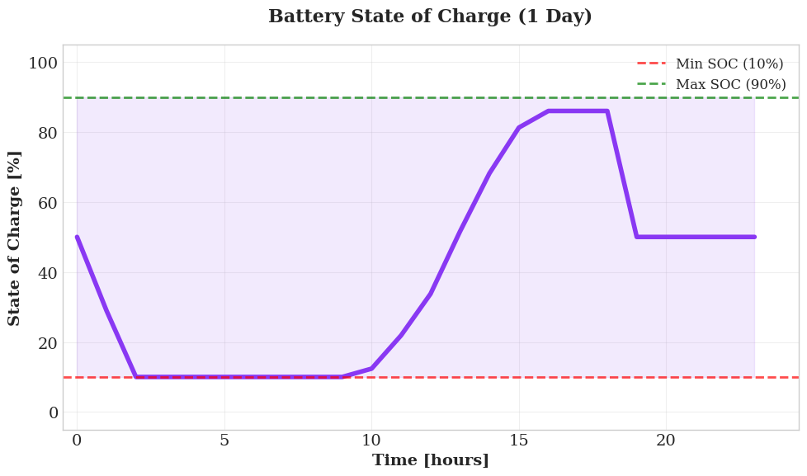

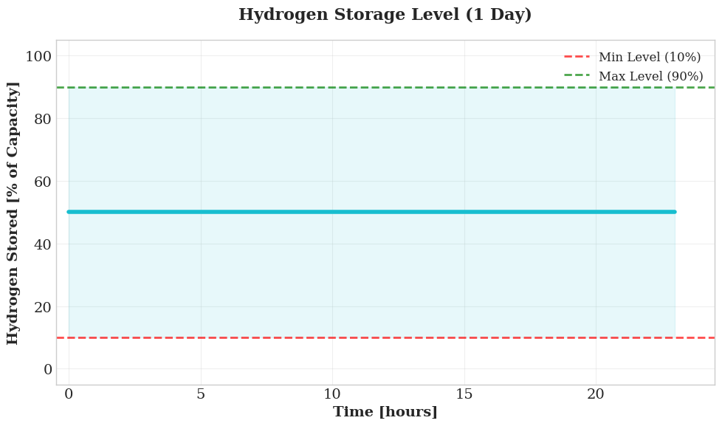

Cost Minimization
SUMMARY REPORT
Optimization Mode: Cost minimization
Optimization Period: 1 day(s)
Time Resolution: 60 minutes
Total Time Steps: 24
LOAD ANALYSIS:
Total Load Demand: 25100.0 kWh
Total Load Curtailed: 0.0 kWh
Total Load Served: 25100.0 kWh (100.0%)
GRID ANALYSIS:
Grid Import: 15822.5 kWh
Grid Export: 4119.2 kWh
DIESEL GENERATOR ANALYSIS:
Energy Generated: 0.0 kWh
Fuel Cost: 0.00 INR
BATTERY ANALYSIS:
Energy Charged: 1684.2 kWh
Energy Discharged: 1520.0 kWh
SOLAR ANALYSIS:
Solar Available: 14500.0 kWh
Solar Used: 14500.0 kWh (100.0%)
Solar Curtailed: 0.0 kWh
HYDROGEN SYSTEM ANALYSIS:
Energy to Electrolyzer: 1738.3 kWh
Energy from Fuel Cell: 799.2 kWh
Hydrogen Produced: 40.00 kg
Hydrogen Consumed: 40.00 kg
Fuel Cell O&M Cost: 1198.80 INR
Round-Trip Efficiency: 46.0%
Effective Conversion: 43.46 kWh/kg

CO₂ EMISSIONS ANALYSIS:
Grid Emissions: 11328.92 kg CO₂
Diesel Emissions: 0.00 kg CO₂
Battery Emissions: 44.08 kg CO₂
PV Emissions: 667.00 kg CO₂
Fuel Cell Emissions: 0.80 kg CO₂
Electrolyzer Emissions: 0.00 kg CO₂
──────────────────────────────────
TOTAL CO₂ (physical): 12040.80 kg CO₂
Emissions per kWh served: 0.4797 kg CO₂/kWh

COST BREAKDOWN (objective):
Grid Cost: 45567.20 INR
Diesel Fuel Cost: 0.00 INR
Solar Cost: 41325.00 INR
Battery O&M Cost: 9249.20 INR
Fuel Cell O&M Cost: 1198.80 INR
Electrolyzer O&M Cost: 869.15 INR
──────────────────────────────────
TOTAL COST: 98209.36 INR
Cost per kWh served: 3.91 INR/kWh

SYSTEM CONFIGURATION:
✓ Grid Connection
✓ Diesel Generator
✓ Battery System
✓ Solar PV
✓ Hydrogen System (Electrolyzer + Fuel Cell)
Weather: Sunny Day

